Using your Own Device
Apps your student(s) may need for Remote Learning. Apps can be installed on smart phones, iPad, Windows 10 computers and Mac computer. Be sure to check with your student’s teachers to determine what method they will be delivering content to your child.
Microsoft Teams
Microsoft Translator

Microsoft Teams on Laptop Computer (if need)
- Open an internet browser (Chrome or Edge)
Did you know
Students can install office for free!
- Go to http://office.com
  - Log in with student email address and password if prompted

- Select Teams from the list
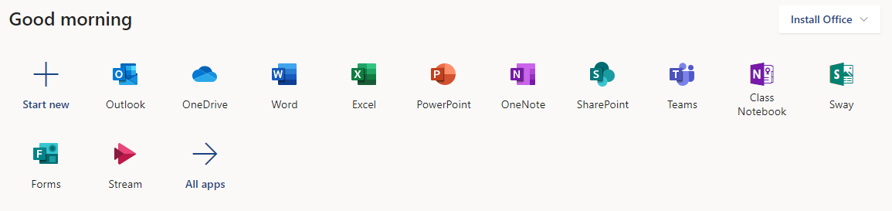

- In the top right corner select the circle (could contain your student’s picture or initials)

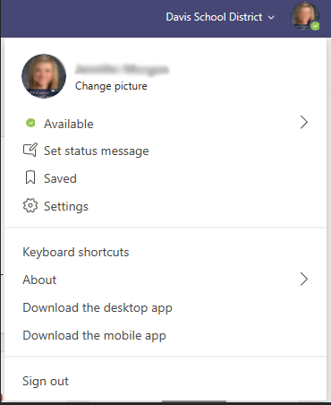
- Select Download the Desktop App

  - After the app has download you will be prompted to install or open it.
  - After it has been installed Teams will open (this may take up to 5 minutes).
  - After Teams has installed you will see the icon on the desktop
  - Student will be prompted to log in with our username and password

- Once Teams has been installed student can access digital content, assignments and communicate with teachers.

- Student can watch the following video to learn how to use Teams
Click here to learn more about Teams
https://bit.ly/2vZtZSW

