Remote Learning
Parents and Guardians, thank you so much for your dedication to your student’s education and for your flexibility. As we adapt to this new learning environment we are asking for your flexibility and patience. The following instructions will help your student(s) get connected to your home wifi, signed in and apps installed

Get connected
- Turn on the computer. Power buttons are in a variety of locations, including the top of the screen, below the screen above the keyboard, or on the right of left side of the device.

- Select the in the lower right corner of the screen

- Choose your wireless network from the list. If your network is not showing up, restart the device.
  - Enter your network password (if needed)

- Have your child log in with their entire email address and pin number

NOTE: The log in may take a few minutes the first time. If multiple children are using the device, each child will need to log in with their own log in information. This will simplify students accessing their digital tools and class materials

- After each use your student should restart the computer, plug in and set aside in a safe place.

Installing Apps
Students may need install apps in order to participate in some class activities. If you are using your own device, apps can be installed from your respective store (Microsoft, Google Play Store, or Apple Store)
1

Microsoft Store on Windows 10 Device
2
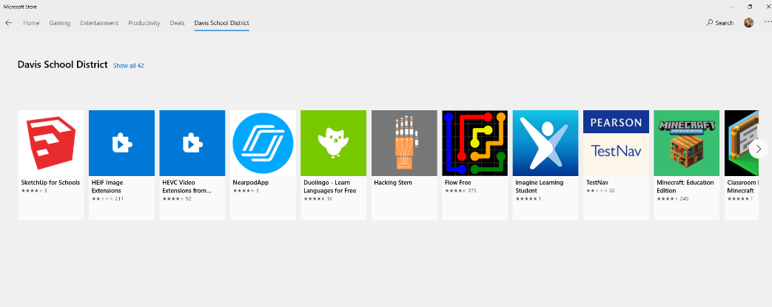
To install apps on a district laptop device
3
- Open the Microsoft Store

- Select the Davis School District Store
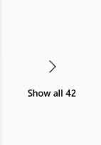
4
- Expand the store to see all the apps

- Select All >

- Select the first app you want to install and choose Install
  - continue to install each app as directed by your child’s teacher. Installation of apps will need to be done once for EACH child after then have logged in.
  - Recommend apps: Nearpod, Minecraft Education Edition, Flipgrid, Microsoft Whiteboard, Office Lens. PLEASE DO NOT INSTALL ALL APPS AVAILBLE IN THE STORE
Student may be using online platforms like Teams or Canvas to access digital content, communicate with teachers, and access assignments. If your student’s teacher is using Microsoft Teams it would be advantageous to install Teams. Canvas can be accessed via the district website under the Quick Links button

Installing Teams
- Open an internet browser (Chrome or Edge)

- Go to http://office.com
  - Log in with student email address and password if prompted

- Select Teams from the list
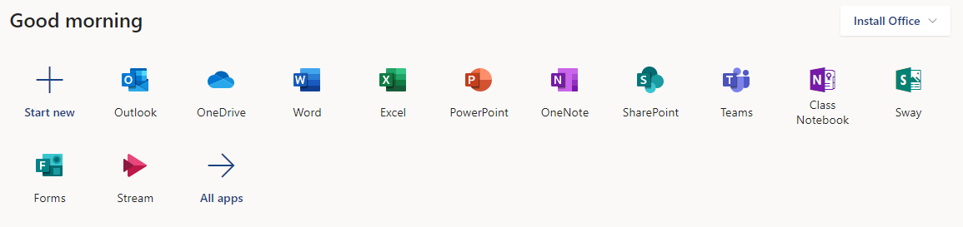

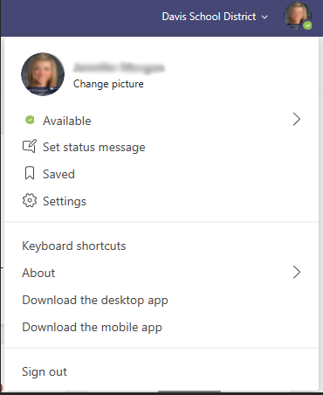
- In the top right corner select the circle (could contain your student’s picture or initials)

- Select Download the Desktop App

  - After the app has downloaded, you will be prompted to install or open it.
  - After it has been installed Teams will open (this may take up to 5 minutes).
  - After Teams has installed you will see the icon on the desktop
  - Students will be prompted to log in with their username and password

Filtering & Monitoring

Filtering and Monitoring
School devices will still be receiving district filtering once they are connected to Wi-Fi. Your student will not be able to access in appropriate content.

